**Learning Outcomes**

1. Understanding android UI and controls
2. Working with xml layout files

**Creating a Simple Calculator**

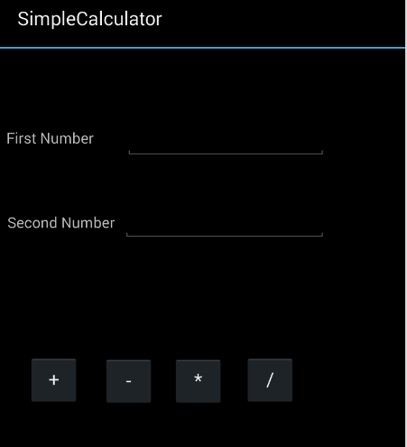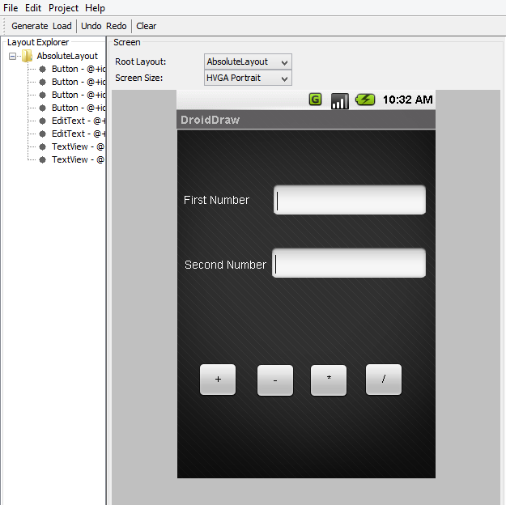

Create a layout as with two textboxes, labels and four buttons as shown above using Droiddraw.

<?xml version="1.0" encoding="utf-8"?>  
<AbsoluteLayout xmlns:android="http://schemas.android.com/apk/res/android"  
    android:id="@+id/widget0"  
    android:layout_width="fill_parent"  
    android:layout_height="fill_parent">  
    <Button  
        android:id="@+id/btnplus"  
        android:layout_width="50dp"  
        android:layout_height="wrap_content"  
        android:text="+"  
        android:layout_x="26dp"  
        android:layout_y="290dp" />  
    <Button  
        android:id="@+id/btnminus"  
        android:layout_width="50dp"  
        android:layout_height="wrap_content"  
        android:text="-"  
        android:layout_x="97dp"  
        android:layout_y="291dp" />  
    <Button  
        android:id="@+id/btnmul"  
        android:layout_width="50dp"  
        android:layout_height="wrap_content"  
        android:text="*"  
        android:layout_x="163dp"  
        android:layout_y="291dp" />  
    <Button  
        android:id="@+id/btnDivide"  
        android:layout_width="50dp"  
        android:layout_height="wrap_content"  
        android:text="/"  
        android:layout_x="231dp"  
        android:layout_y="290dp" />  
    <EditText  
        android:id="@+id/txtNum1"  
        android:layout_width="192dp"  
        android:layout_height="wrap_content"  
        android:textSize="18sp"  
        android:numeric="decimal"  
        android:layout_x="118dp"  
        android:layout_y="68dp" />  
    <EditText  
        android:id="@+id/txtNum2"  
        android:layout_width="194dp"  
        android:layout_height="wrap_content"  
        android:textSize="18sp"  
        android:layout_x="116dp"  
        android:layout_y="146dp" />  
    <TextView  
        android:id="@+id/widget44"  
        android:layout_width="wrap_content"  
        android:layout_height="wrap_content"  
        android:text="First Number"  
        android:layout_x="6dp"  
        android:layout_y="77dp" />  
    <TextView  
        android:id="@+id/widget45"  
        android:layout_width="wrap_content"  
        android:layout_height="wrap_content"  
        android:text="Second Number"  
        android:layout_x="7dp"  
        android:layout_y="157dp" />  
</AbsoluteLayout>

Before writing the code build your project so that the resource file is set up.

Declare the controls

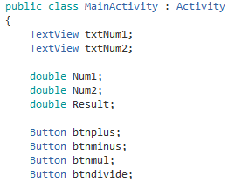

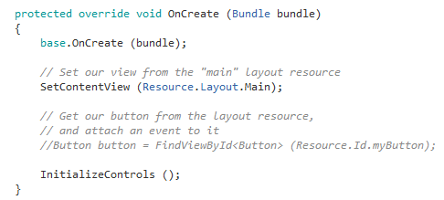

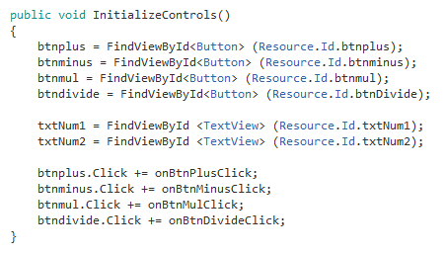

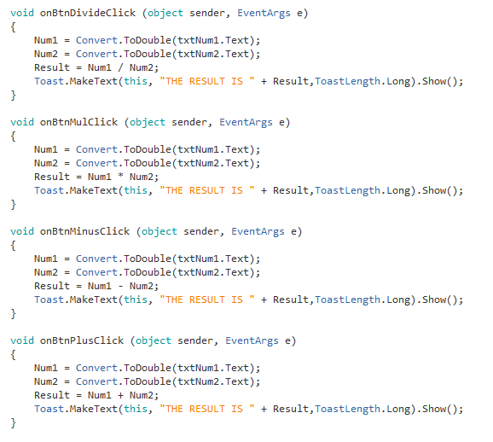

**BMI Calculator**

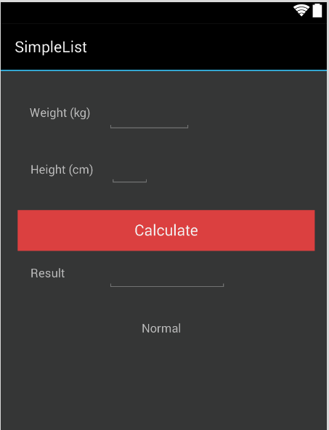

Design an app as shown above using DroidDraw

The formula for BMI goes like this

**BMI = Weight / (Height * Height)**

|  |  |
| --- | --- |
| BMI | Result |
| < 18.5 | Underweight |
| 18.6 to 24.9 | Normal |
| 25 to 29.9 | Overweight |
| > 30 | Obese |

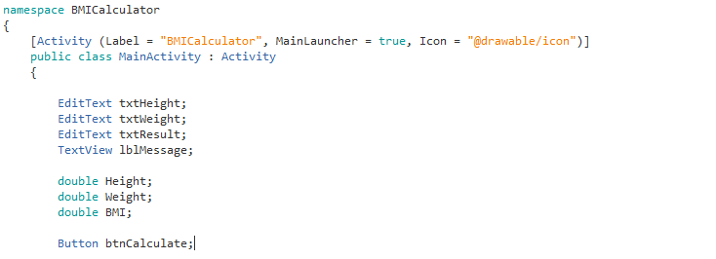

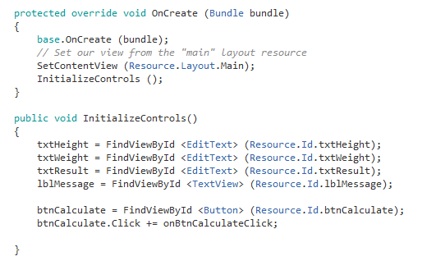

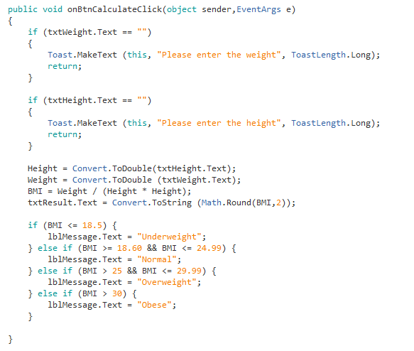

**Exercise**

1. Design a Math Tester